National University of Computer & Emerging Sciences
Karachi Campus


Pakistan Sign Language - Translation and Learning Application
Project Report
Programming for Mobile Devices
Instructor: Sir Ali Fatmi
Section: BSE-8A
Group Members:
Amna Mansoor | BSE-8B | 22K-5159
Hafsa Salman | BSE-8B | 22K-5161

1. Project Overview and Objectives

1.1 Introduction
This project introduces a comprehensive Sign Language Translation and Learning Application designed for mobile devices. The application serves a dual purpose: it acts as an interactive educational platform for users wanting to learn sign language, and it provides a foundational interface for AI-driven sign-to-text translation using native mobile hardware.

1.2 Problem Statement
There is a significant communication barrier between the speech-and-hearing-impaired community and the general public. While physical classes exist to teach sign language, accessible, on-the-go digital learning tools are limited. Furthermore, real-time translation tools require complex hardware setups that are not accessible to everyday smartphone users.

1.3 Project Objectives
From a mobile programming perspective, the core objectives of this project are to:
- Develop a Cross-Platform Mobile Application: Utilize a modern framework to build an application that performs seamlessly on mobile hardware (specifically tested on Android devices like the Redmi 13 Pro).
- Integrate Native Hardware APIs: Successfully request permissions and utilize the mobile device's camera and local file system (gallery) to capture and process video data.
- Implement Modern Mobile UI/UX: Design a highly responsive, aesthetically pleasing interface utilizing soft gradients, custom pill-shaped toggles, and dynamic progress indicators that adhere to modern mobile design guidelines.
- Integrate a Mobile Backend-as-a-Service (MBaaS): Connect the application to a cloud database for real-time synchronization of educational content (chapters, words, and video URLs).

2. System Architecture

2.1 High-Level Architecture
The application follows a standard Client-Server architecture optimized for mobile platforms.
- Presentation Layer (Client): This is the mobile application residing on the user's device. It is responsible for rendering the UI, handling touch events, managing local state (e.g., quiz progress), and playing media.
- Hardware Abstraction Layer: The application communicates with the device's OS to access the camera hardware and local storage to capture .mp4 video files.
- Data/Backend Layer (Server): The cloud infrastructure acts as the single source of truth, storing chapter metadata, vocabulary lists, and hosting the video assets streamed to the mobile device.

2.2 Data Flow
When a user navigates to the dictionary, the mobile client makes an asynchronous request to the cloud database. The data is serialized into Dart objects, and the UI tree is rebuilt to display the fetched chapters. During the translation process, the data flow shifts locally: the app triggers the OS camera intent, captures a video stream into the device's temporary cache, and passes the file path back to the application state for future AI processing.

3. Technologies Used

3.1 Frontend Development
- Flutter & Dart: Chosen for its high-performance rendering engine and ability to compile directly to native ARM code. This ensures smooth 60fps animations for gradients, interactive quiz elements, and video playback.
- State Management: Utilized Flutter's native StatefulWidget and TabController for managing localized screen states, such as tracking quiz scores and toggling between learning and testing modes.

3.2 Backend and Services
- Firebase Cloud Firestore: A NoSQL cloud database chosen for its robust mobile SDKs. It allows the app to fetch structured chapter and vocabulary data with minimal latency.
- Firebase Authentication (Planned/Implemented): Used for managing user sessions and securely storing quiz progress/scores.

3.3 Native Mobile Plugins
- image_picker (v1.0.7): A crucial plugin utilized in the Translation module. It interfaces directly with the Android/iOS native APIs to request camera permissions, launch the native video recording UI, and access the device's media gallery.
- video_player: Integrated to stream and render .mp4 files directly within the app's widget tree, allowing users to watch sign language demonstrations seamlessly.

4. Database Design
Because the application requires fast, read-heavy operations to populate the UI, a NoSQL document-based structure was chosen over a traditional relational database.

4.1 Data Collections
Chapters Collection: Stores the high-level categories of the dictionary.
- id (String): Unique identifier.
- name (String): The title of the chapter (e.g., "Banking", "Anatomy"). The app uses regular expressions to dynamically format these names on the client side.
Words Collection: Stores the individual sign language entries.
- id (String): Unique identifier.
- chapterId (String): Foreign key linking the word to its specific chapter.
- word (String): The text translation of the sign.
- videoUrl (String): The remote URL pointing to the video asset.
Quiz_Scores Collection (Optional): Tracks user performance.
- userId (String), chapterId (String), score (Integer).
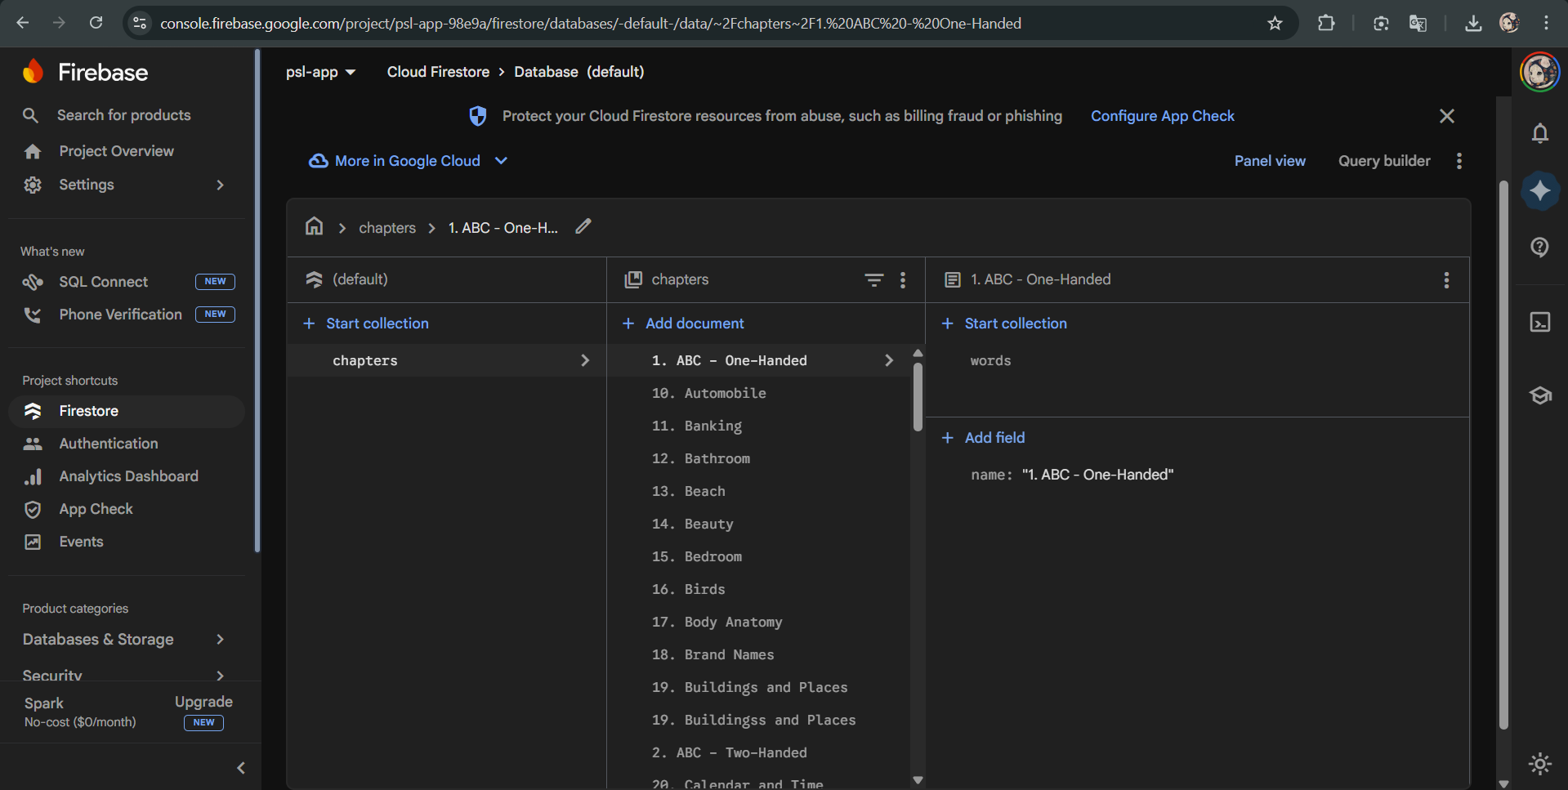

5. Application Features and Screenshots

5.1 Interactive Dictionary Chapters
The application features a modern grid-based dictionary. Instead of standard lists, chapters are presented in visually distinct cards. The data is fetched asynchronously from Firebase, and text is dynamically cleaned (removing numerical prefixes) before rendering.
[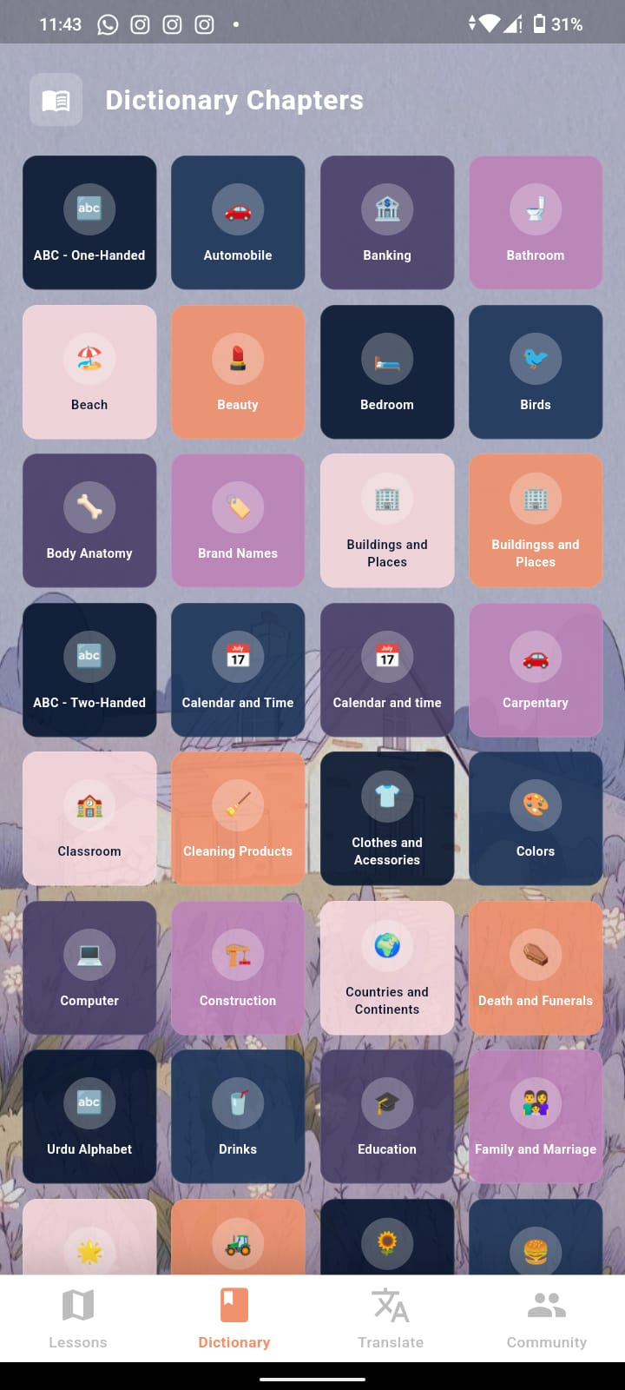
Figure 1: The dictionary interface displaying dynamically fetched chapters.

5.2 Lesson and Quiz Hub
Once a chapter is selected, users are taken to the lesson hub. This screen utilizes a custom-built, sleek pill-shaped toggle (TabBar) to switch between educational videos and interactive testing, layered over a modern gradient background.

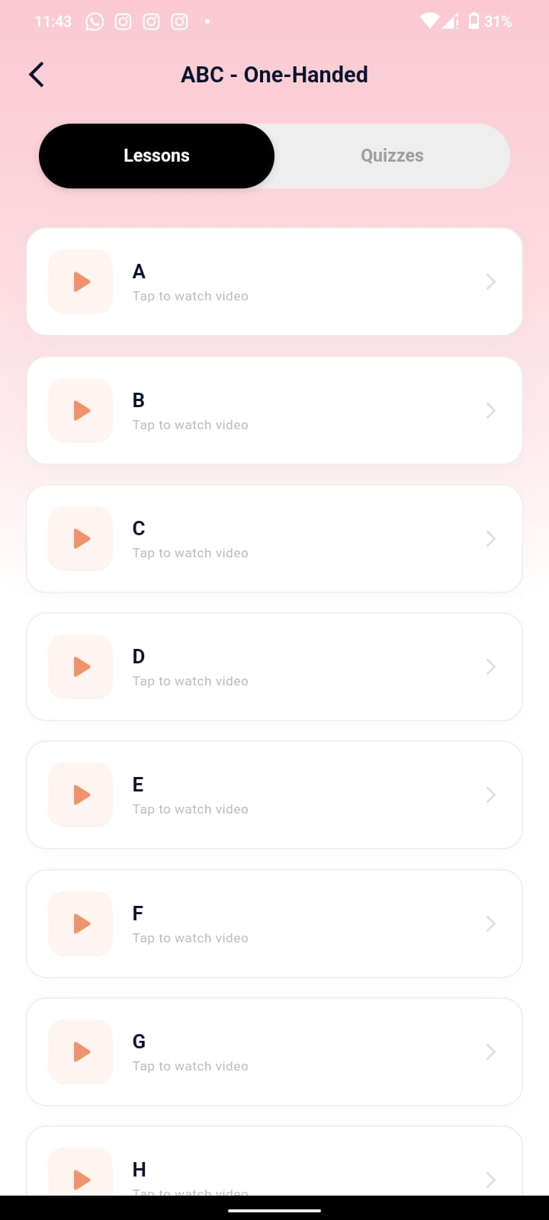
Figure 2: Custom tab interface allowing users to toggle between studying signs and taking quizzes.

5.3 Dynamic Interactive Quizzes
The quiz module dynamically generates multiple-choice questions based on the selected chapter. It pulls the correct video and generates "distractor" options from the rest of the vocabulary pool. It features a responsive progress bar, custom state styling (green for correct, red for incorrect), and a polished results dialog.

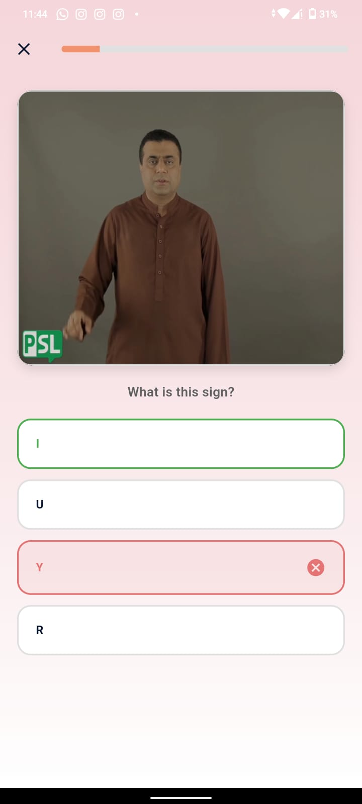
Figure 3: A generated quiz question featuring video playback and interactive options.

5.4 Native Camera & Translation Module
The Translation View leverages mobile hardware integration. Users are presented with distinct action cards to either open their native camera to record a sign or browse their gallery. To manage user expectations, a custom animated "Coming Soon" modal dialog is triggered upon completing the hardware interaction.

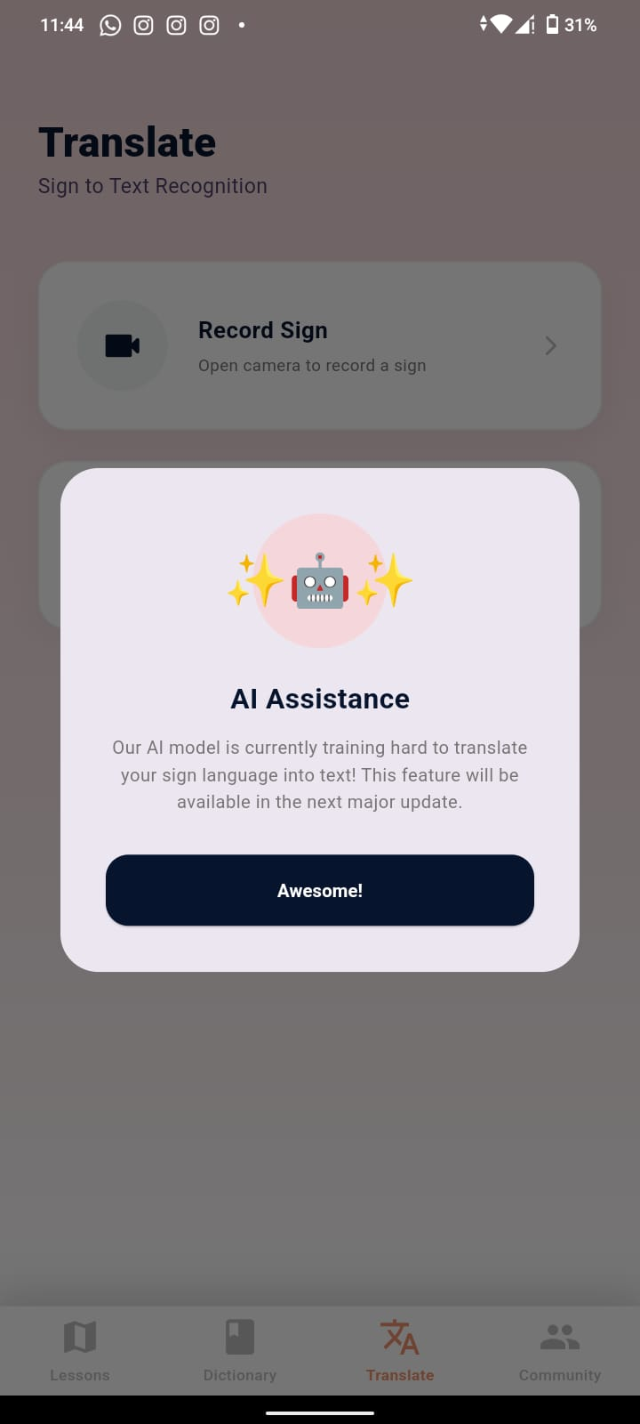
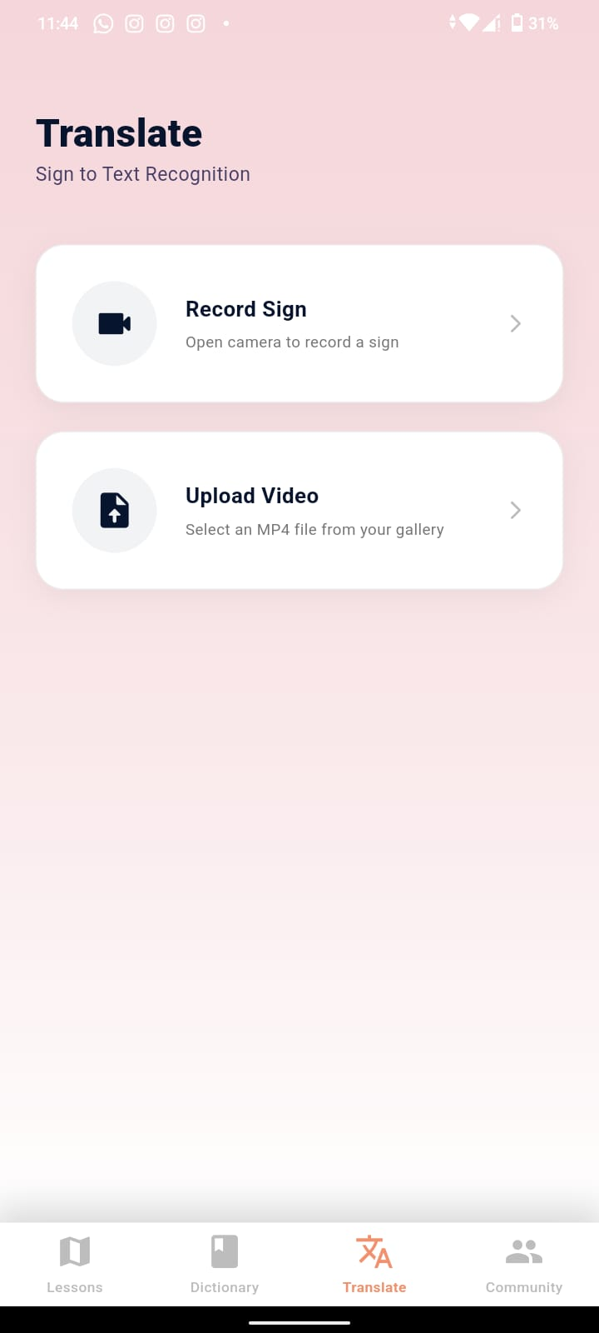
Figure 4 & 5: The translation interface showcasing native hardware triggers and custom modal dialogs.

6. Testing and Results

6.1 Testing Methodology
The application underwent rigorous manual testing specifically targeted at mobile functionality. Testing was conducted on a physical Redmi 13 Pro device using USB debugging (adb) to ensure native features performed correctly outside of an emulator environment.

6.2 Key Test Cases

Feature Tested | Action/Input | Expected Result | Actual Result | Status
Data Fetching | Open Dictionary Screen | App asynchronously fetches and displays Firebase chapters. | Chapters load with cleaned text formatting. | Pass
Media Playback | Open Lesson Tab | Video player initializes and loops the sign language video. | Video plays smoothly within the cropped container. | Pass
Camera API | Tap "Record Sign" in Translation tab | OS requests camera permissions and opens video recorder. | Native camera opens successfully. | Pass
Gallery API | Tap "Upload Video" | OS opens local file explorer to select .mp4. | Gallery opens; upon selection, modal triggers. | Pass
Quiz Logic | Select incorrect option | Button turns red, correct option turns green, auto-advances. | State updates correctly with 1-second delay. | Pass

6.3 Conclusion and Results
The application successfully meets the objectives of the mobile programming course. It demonstrates a strong understanding of cross-platform UI development, asynchronous state management, backend integration via Firebase, and vital native hardware interactions. The user interface remains highly responsive, and the core educational loop (learn, practice, quiz) functions flawlessly on physical mobile hardware. Future enhancements will focus on connecting the fully trained AI model to the camera module to process the captured video files locally or via an API.

